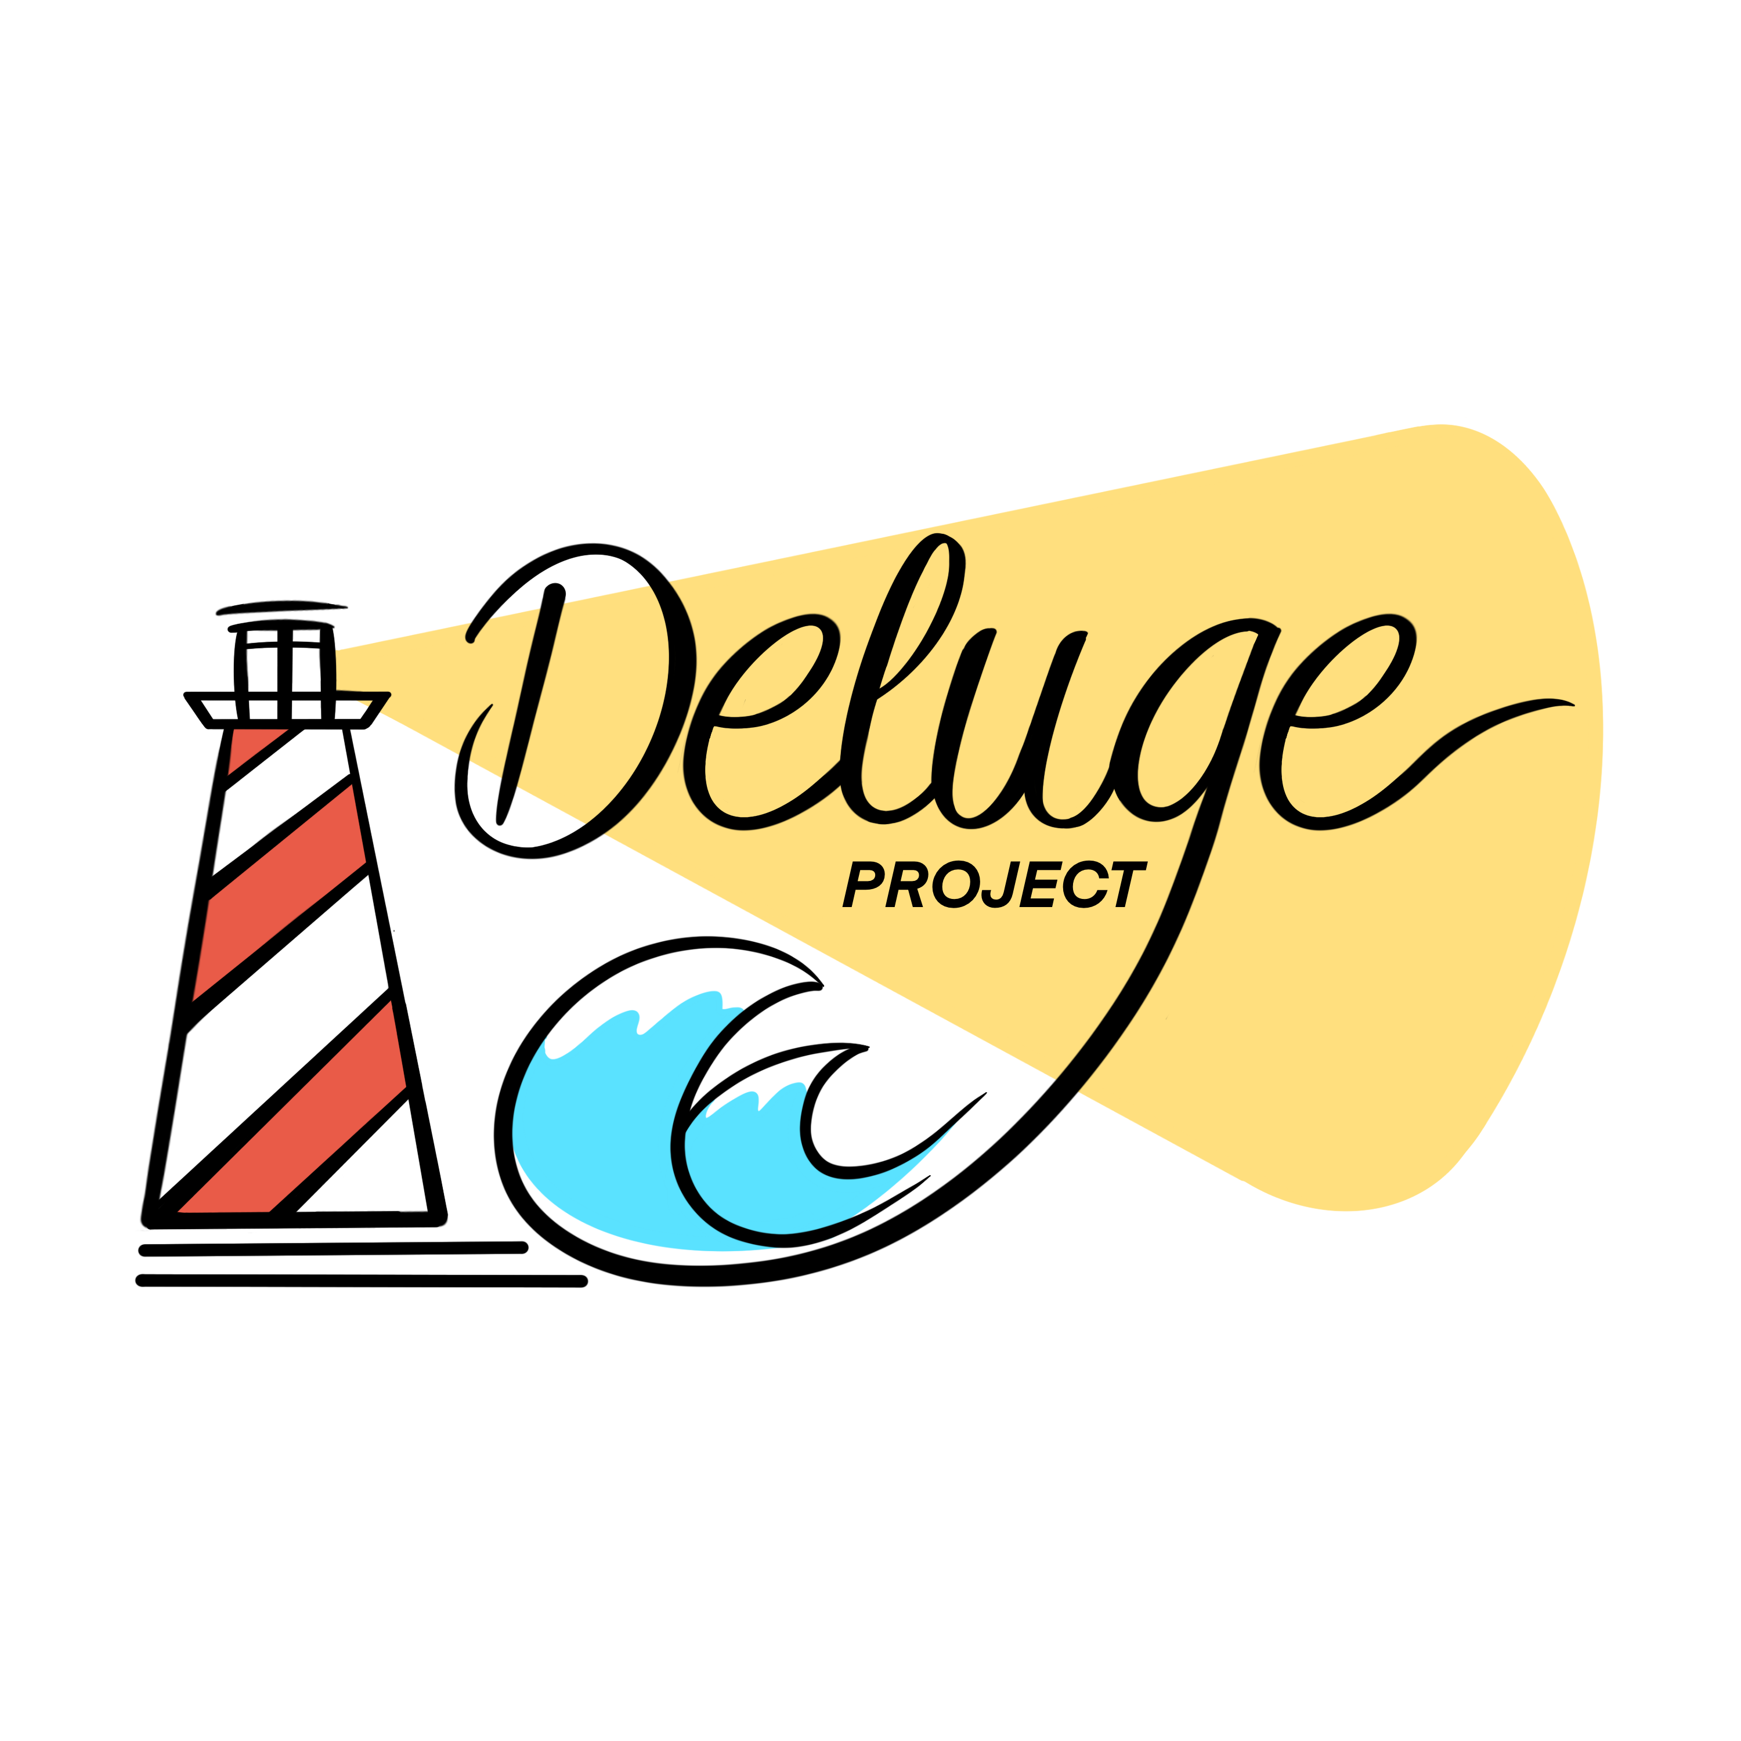

Dear Parent/Guardian,

On Friday 7th, Saturday 8th and Sunday 9th July we are planning to take a group from [YOUTH GROUP NAME] to the Deluge Weekend, a Christian youth event being held at YWAM The Kings Lodge which is gathering local youth groups for worship, prayer and outreach. Go to [www.ywamwildfire.com/delugeprojectweekend](http://www.ywamwildfire.com/delugeprojectweekend) for more information.

The cost of the event is £20 per head, which includes Friday evening activities, Saturday all-day activities plus evening meal, and the Sunday fun afternoon (more details about the timings and activities can be found at the above link). However, if finance would still prove to be a preventative issue, please contact me as we would like to help make it possible for your child to attend.

*\*Delete as appropriate*

*If your child wishes to come, please fill in the attached form and return it to me with your £20 payment by [INSERT DATES].

*If your child wishes to come, please fill in the attached form and return it to me by [INSERT DATES]. When you fill in the form, please follow the link to book your child in to the event: [www.ywamwildfire.com/delugeprojectweekend](http://www.ywamwildfire.com/delugeprojectweekend)

Your child will be supervised by members of the youth team. All team members are fully DBS checked and approved. The group will not stay overnight, but attend as day visitors from the Friday evening. If your child would like to attend but cannot make all the days, please get in touch with me to discuss.

There will be more information about the weekend which I will pass on to you closer to the event. If you have any questions at this time, please do feel free to contact me.

Yours Faithfully,

[INSERT NAME AND CONTACT DETAILS]

**Parental Consent, Medical and Dietary form**

CHILD NAME: __________________________________________________________

PARENT / GUARDIAN NAME: _____________________________________________

ANY MEDICAL CONDITIONS: _____________________________________________

MEDICATION REQUIRED: ________________________________________________

ANY DIETRY REQUIREMENTS: ___________________________________________

IN CASE OF EMERGENCY, PLEASE CONTACT:

NAME: ________________________________________________________________

ADDRESS: ______________________________________________________________________

HOME TELEPHONE: ____________________________________________________

MOBILE: _______________________________________________

I give permission for my child to attend the Deluge Weekend.

I give permission for photographs of my child to be used in [YOUTH GROUP NAME] social media.

I give permission for photographs of my child to be used in YWAM King’s Lodge social media.

I give permission for the youth team to contact my child directly to help make arrangements for the event.

I enclose the full payment of £20

SIGNED: _____________________________________________